**Tutorial – 2**

1. Implement Java program to create a class Student with data ‘name, city and age’ along with the method printData to display the data. Create the two objects s1 ,s2 to  declare and access the values.

**Code:**

class Student {

    private String name;

    private String city;

    private int age;

    public Student(String name, String city, int age) {

*this*.name = name;

*this*.city = city;

*this*.age = age;

    }

    public void printData() {

        System.out.println("Name: " + *this*.name);

        System.out.println("City: " + *this*.city);

        System.out.println("Age: " + *this*.age);

    }

}

public class main21 {

    public static void main(String[] args) {

        Student s1 = new Student("Viraj Chhayani", "Jasdan", 20);

        Student s2 = new Student("Mayank", "Jamnagar", 19);

        s1.printData();

        System.out.println("\n");

        s2.printData();

    }

}

**Output Screenshot:**

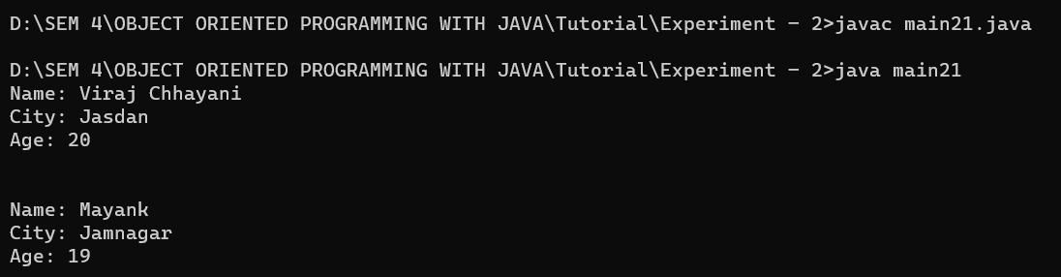

1. Implement a java program to create a class Employee display the employee details such as employee id, employee name, salary, age using Scanner class. Create Employee class to object and display employee details.

**Code:**

import java.util.Scanner;

class Employee {

  int employeeId;

  String employeeName;

  double salary;

  int age;

  public void inputDetails() {

    Scanner sc = new Scanner(System.in);

    System.out.print("Enter Employee ID: ");

    employeeId = sc.nextInt();

    System.out.print("Enter Employee Name: ");

    employeeName = sc.next();

    System.out.print("Enter Employee Salary: ");

    salary = sc.nextDouble();

    System.out.print("Enter Employee Age: ");

    age = sc.nextInt();

  }

  public void displayDetails() {

    System.out.println("Employee ID: " + employeeId);

    System.out.println("Employee Name: " + employeeName);

    System.out.println("Employee Salary: " + salary);

    System.out.println("Employee Age: " + age);

  }

}

public class EmployeeDetails {

  public static void main(String[] args) {

    Employee e = new Employee();

    System.out.println("Enter the details of employee:");

    e.inputDetails();

    System.out.println("\nDetails of Employee:");

    e.displayDetails();

  }

}

**Output Screenshot:**

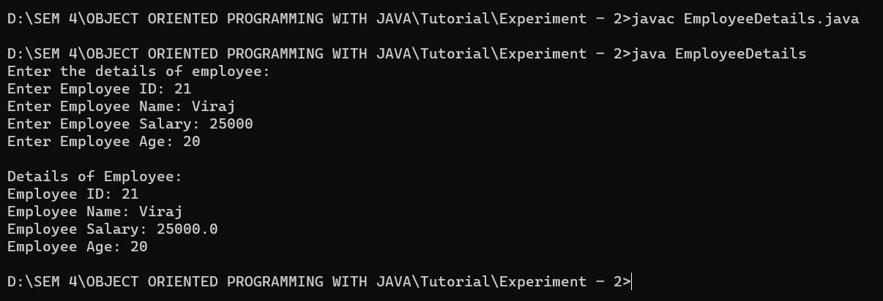

1. Design a class to represent a bank account. Which contains account number, name of the depositor, type of the account, balance amount in the account. Use constructors to assign initial values, to Deposit an amount, to Withdraw amount after checking balance, to display name and balance.

**Code:**

class BankAccount {

  private int accountNumber;

  private String name;

  private String type;

  private double balance;

  public BankAccount(int accountNumber, String name, String type, double balance) {

*this*.accountNumber = accountNumber;

*this*.name = name;

*this*.type = type;

*this*.balance = balance;

  }

  public void deposit(double amount) {

*this*.balance += amount;

  }

  public boolean withdraw(double amount) {

    if (*this*.balance >= amount) {

*this*.balance -= amount;

      return true;

    }

    return false;

  }

  public void displayInfo() {

    System.out.println("Name: " + *this*.name);

    System.out.println("Balance: " + *this*.balance);

  }

}

public class BankA {

  public static void main(String[] args) {

    BankAccount account = new BankAccount(12345, "Viraj Chhayani", "Saving", 10000.0);

    account.displayInfo();

    account.deposit(1500.0);

    System.out.println("After deposit:");

    account.displayInfo();

    boolean result = account.withdraw(5000.0);

    if (result) {

      System.out.println("Withdrawal successful.");

      System.out.println("After withdrawal:");

      account.displayInfo();

    } else {

      System.out.println("Insufficient balance.");

    }

  }

}

**Output:**

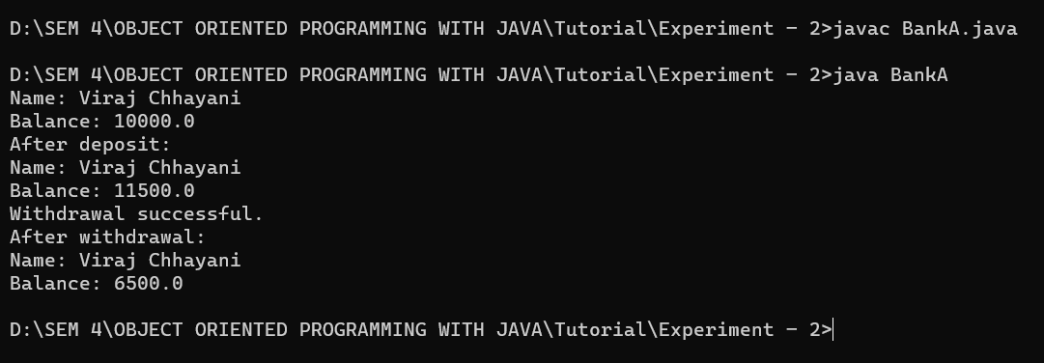

1. Java Program to Find Area of Square, Rectangle and Circle using Method Overloading.

**Code:**

public class AreaCalculator {

    public static void main(String[] args) {

        Rectangle obj = new Rectangle();

        obj.Area(30, 20);

        obj.Area(12.5, 4.5);

        Circle obj1 = new Circle();

        obj1.Area(3);

        obj1.Area(5.5);

        Square obj2 = new Square();

        obj2.Area(20);

        obj2.Area(5.2);

    }

}

class Square {

    void Area(double side) {

        System.out.println("Area of the Square: " + side * side);

    }

    void Area(float side) {

        System.out.println("Area of the Square: " + side * side);

    }

}

class Circle {

    static final double PI = Math.PI;

    void Area(double r) {

        double A = PI * r * r;

        System.out.println("The area of the circle is :" + A);

    }

    void Area(float r) {

        double A = PI * r * r;

        System.out.println("The area of the circle is :" + A);

    }

}

class Rectangle {

    void Area(double l, double b) {

        System.out.println("Area of the rectangle: " + l * b);

    }

    void Area(int l, int b) {

        System.out.println("Area of the rectangle: " + l * b);

    }

}

**Output:**

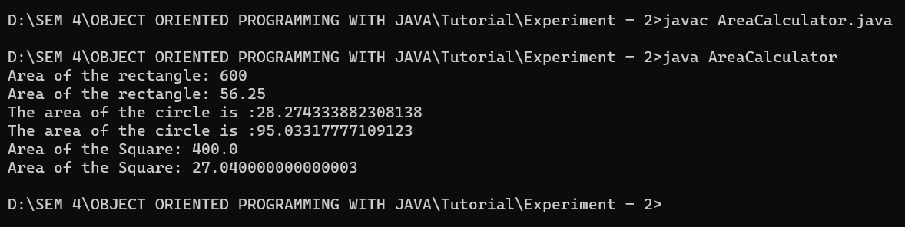

1. Implement a java program create class Box with necessary member  for calculate volume of Box and display it with method name Volume. Create Box class object and to display volume of Box.

**Code:**

class Box {

    double width;

    double height;

    double depth;

    public Box(double width, double height, double depth) {

*this*.width = width;

*this*.height = height;

*this*.depth = depth;

    }

    public double volume() {

        return width * height * depth;

    }

}

public class Volum {

    public static void main(String[] args) {

        Box myBox = new Box(100, 50, 75);

        System.out.println("Volume of box is: " + myBox.volume());

    }

}

**Output:**

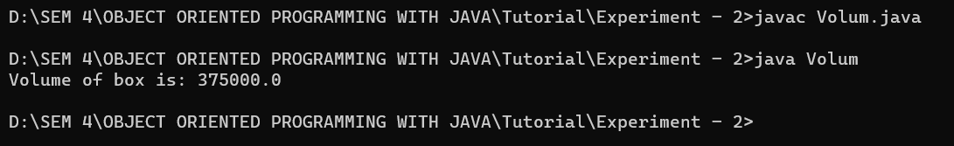

1. Implement java program to create class Person with data member like age, name ,address, mobile number. and declare them as private along with method to take input of data member getinput() and for display details show(). Create Person class object and display details.

**Code:**

class Person {

    private int age;

    private String name;

    private String address;

    private String mobileNumber;

    public void getInput() {

        System.out.print("Enter Age: ");

        age = new java.util.Scanner(System.in).nextInt();

        System.out.print("Enter Name: ");

        name = new java.util.Scanner(System.in).nextLine();

        System.out.print("Enter Address: ");

        address = new java.util.Scanner(System.in).nextLine();

        System.out.print("Enter Mobile Number: ");

        mobileNumber = new java.util.Scanner(System.in).nextLine();

    }

    public void show() {

        System.out.println("Age: " + age);

        System.out.println("Name: " + name);

        System.out.println("Address: " + address);

        System.out.println("Mobile Number: " + mobileNumber);

    }

}

public class Main {

    public static void main(String[] args) {

        Person person = new Person();

        System.out.println("Enter details for person:");

        person.getInput();

        System.out.println("Details for person:");

        person.show();

    }

}

**Output:**

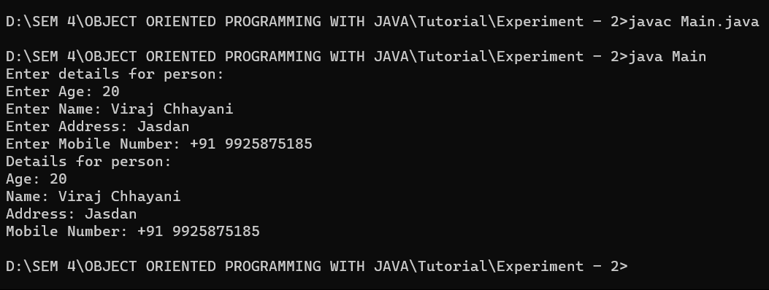

1. Consider 2 program problem in which add condition for which employee get highest salary and display that salary with necessary employee details.

**Code:**

import java.util.Scanner;

class Employee {

  private int id;

  private String name;

  private double salary;

  public Employee(int id, String name, double salary) {

*this*.id = id;

*this*.name = name;

*this*.salary = salary;

  }

  public int getId() {

    return id;

  }

  public String getName() {

    return name;

  }

  public double getSalary() {

    return salary;

  }

}

public class Main1 {

  public static void main(String[] args) {

    Scanner scan = new Scanner(System.in);

    System.out.println("Enter the number of employees: ");

    int n = scan.nextInt();

    Employee[] employees = new Employee[n];

    scan.nextLine();

    for (int i = 0; i < n; i++) {

      System.out.println("Enter the details of employee " + (i + 1) + " (id name salary): ");

      String[] details = scan.nextLine().split(" ");

      int id = Integer.parseInt(details[0]);

      String name = details[1];

      double salary = Double.parseDouble(details[2]);

      employees[i] = new Employee(id, name, salary);

    }

    double maxSalary = Double.MIN_VALUE;

    int maxEmployeeIndex = -1;

    for (int i = 0; i < n; i++) {

      if (employees[i].getSalary() > maxSalary) {

        maxSalary = employees[i].getSalary();

        maxEmployeeIndex = i;

      }

    }

    System.out.println("The employee with highest salary is: ");

    System.out.println("Id: " + employees[maxEmployeeIndex].getId());

    System.out.println("Name: " + employees[maxEmployeeIndex].getName());

    System.out.println("Salary: " + employees[maxEmployeeIndex].getSalary());

  }

}

**Output:**

